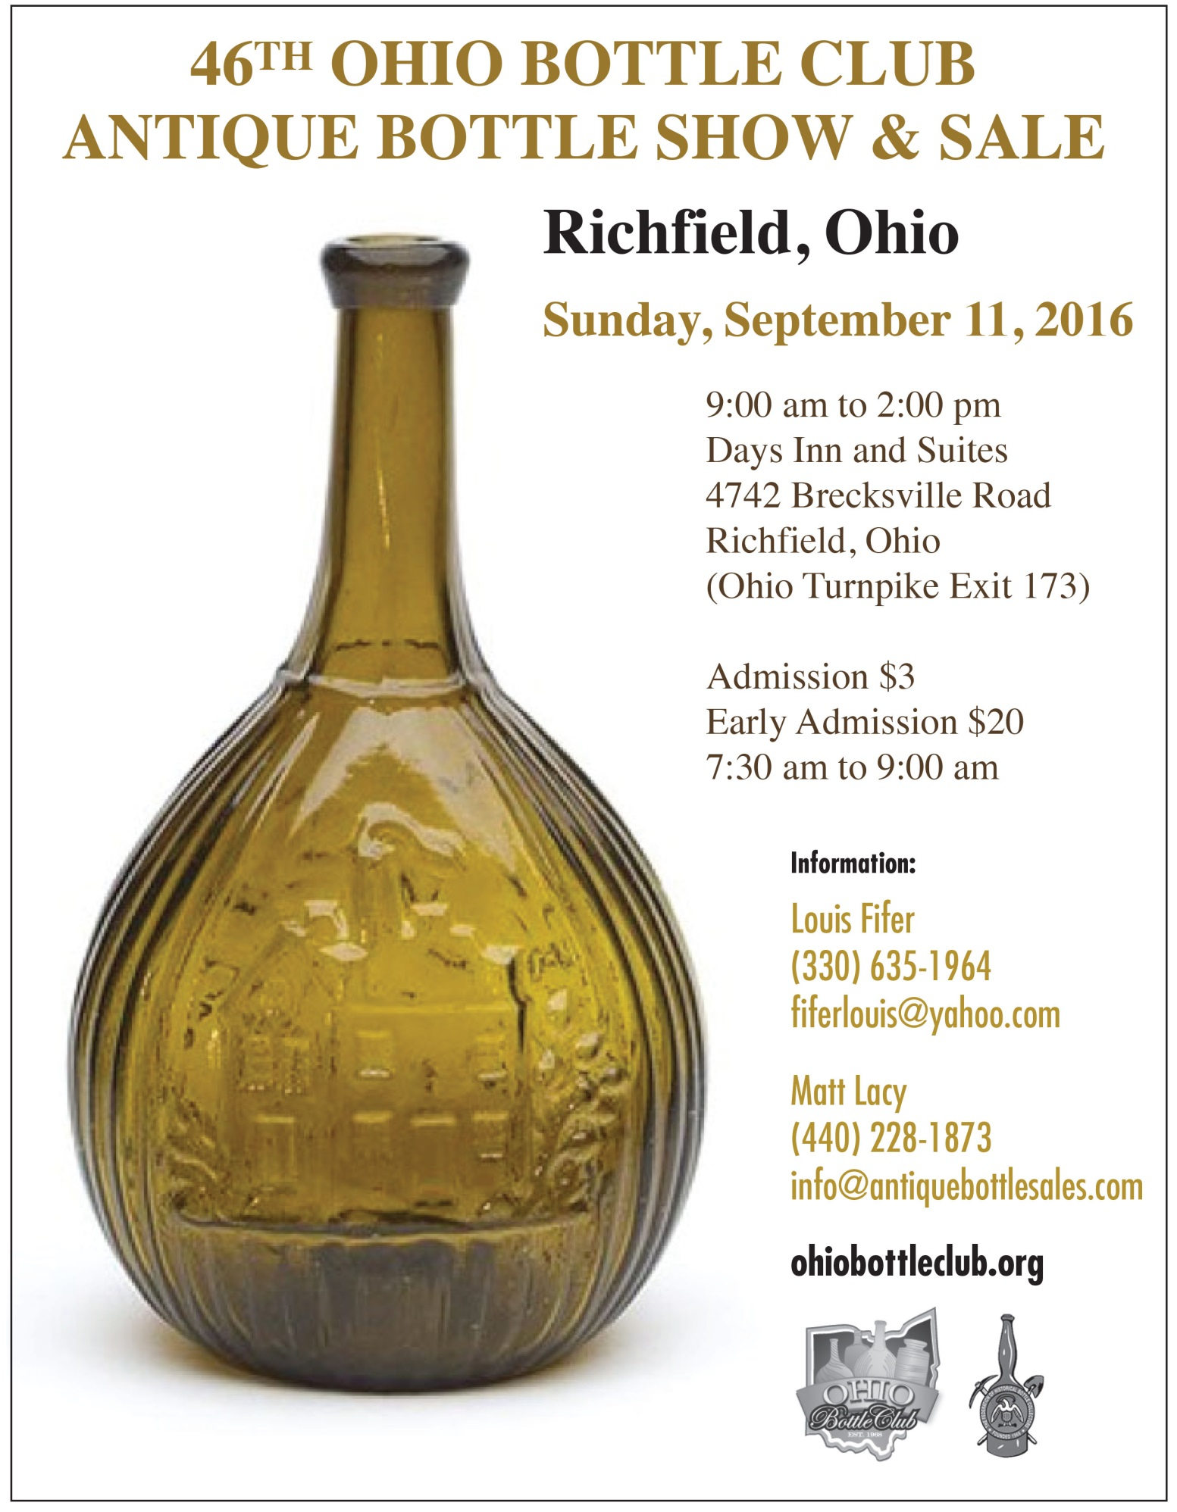

2016 Ohio Bottle Club Antique Bottle Show & Sale
Richfield Ohio

Your invitation to the
Ohio Bottle Club’s Antique Bottle Show and Sale

You’re invited to the Richfield Ohio Antique Bottle Show and Sale at the Day’s Inn and Suites at 4742 Brecksville Road in Richfield, Ohio on Sunday September 11th 2016.
The show is located half way between Cleveland and Akron right off the Ohio turnpike. The hotel furnishes a fully carpeted elegant ballroom with excellent lighting.
This show had a fantastic turnout last year with many compliments from first time dealers that will be returning this year! The highlights include not only the excellent ballroom, but the fantastic dealer dinner the night before.
We will have approximately 85 - 6’ tables in the ballroom with areas for overflow once the ballroom sells out. Tables will be offered on a first come first serve basis starting after the Mansfield 2016 show.
Room rates at the host motel “Days Inn and Suites” are $85.00 plus tax and include a hot breakfast buffet.
This motel has a large indoor atrium area complete with a swimming pool, miniature golf, and children’s play area. So bring your family to a great show, wherefore, $85.00 you can get a nice room, FREE hot breakfast buffet and of course world class food at the hospitality room Saturday evening at 6:30PM.
Yes, we have early admission available at the low cost of $20.00 per person from 7:30am-9am Sunday.
The show is self-sustaining and offers the benefits of meals, accommodations, and socializing all in one location. Don’t miss out on one of the best opportunities of the year to buy and sell great glass!

Testimony:
“My son, Andrew, and I had a wonderful time at last years’ Richfield Ohio show. Some of the most hospitable people you will ever want to meet sponsored the show. The venue is fantastic and there are plenty of good bottles and glass for everyone’s enjoyment. Don’t miss it, it is a real treat.” – Mark Vuono, Stamford CT, 2014
2016 Ohio Bottle Club Antique Bottle Show & Sale
Rules and Basic Information

Sales Tables

RULES
- Dealers may put merchandise under their tables between 7am and 7:30am Sunday September 11th 2016
- Sales tables must be setup between 7:30am-9am
- Sales tables MUST remain setup until 2pm
- All merchandise must be visibly priced. Repairs, reproductions, and radiated items must be noted
- Table covers WILL be supplied
- We will furnish ONLY TWO name tags with each contract which must be worn during setup and show hours

SALES TABLE AVAILABILITY
- Table size is 6’x30” only
- Price is $35 for the first table and $30 for each additional table
- Tables will be assigned on a first come first serve basis, unless you would like your previous space(s). The sooner we get your contract, the more likely you will get last year’s space
- All wall spaces and a limited number of interior tables have electric available at no charge. You must supply your own extension cords

SALES TABLE PAYMENT
- Contracts MUST BE received by August 28, 2016 if you wish to retain your previous location
- Full Payment must be sent with your contract
- Cancellation with full refund will be accepted until August 28, 2016
- Make checks payable to “The Ohio Bottle Club”

2016 Ohio Bottle Club Antique Bottle Show & Sale
Days Inn & Suites - Hotel Accommodations
The hotel cost is $85.00 per night + tax and includes a hot buffet breakfast.
For reservations call the host motel at (330)-659-6151.
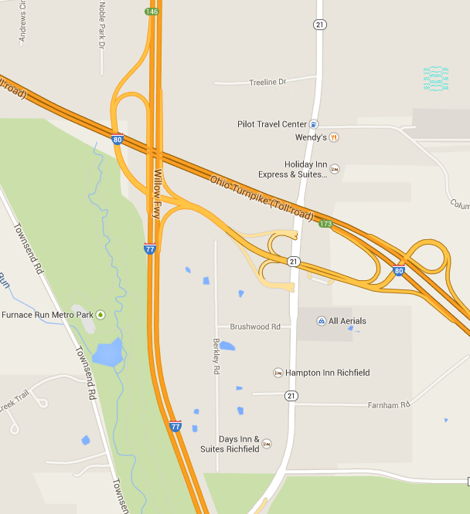
Location of the show is 4742 Brecksville Road, Richfield Ohio, 44286
The hospitality dinner will be held at 6:30pm Saturday evening.
There are several other motels less than ½ mile from the show.

2016 Ohio Bottle Club Antique Bottle Show & Sale
Please complete entirely, sign, and mail to: Ohio Bottle Club, 604 Topaz Lane, Brunswick Ohio, 44212. Make checks payable to: THE OHIO BOTTLE CLUB. Full payment must be sent with this contract.

I, _____________________________, agree to abide by the rules set forth in this sales contract for the Ohio Bottle Club’s Antique Bottle Show and Sale to be held at the Day’s Inn and Suites in Richfield Ohio on September 11th, 2016.

I understand that the Ohio Bottle Club or the show chairman will not be liable or responsible for the theft, damage, or breakage of any merchandise.

NAME: _______________________________ SIGNATURE: ____________________________
ADDRESS: ___________________________________ CITY____________________________
STATE: _________________ ZIP CODE: ______________ PHONE: _____________________
EMAIL:_______________________________________________________________________
No. of people for Saturday Dinner: _______
Number of tables requested________
Type of Merchandise___________________________________________________________
Two Name Badges Per Sales Contract
Name_____________________________ City ______________________ State____________
Name_____________________________ City ______________________ State____________

Total Payment Due with Contract
Inside Sales Table: $35.00 first / $30.00 additional $________________
Early Admission: $20.00 $________________
Total Amount Enclosed $________________

Louis Fifer Richfield Bottle Show 2016
Ohio Bottle Club
604 Topaz Lane
Brunswick Ohio 44212
FIRST CLASS

